Kick Starter Report

**What are three conclusions we can make about Kickstarter campaigns given the provided data?**

After analyzing the data from 4114 Kickstarter campaigns, there are a few conclusions we can make. One conclusion we can come to regarding what types of categories are best suited for Kickstarter.

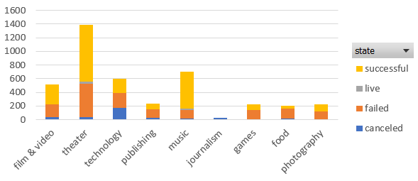

As we can see in the chart above, theater, music, technology, and film/video are the most popular categories on Kickstarter. Out of these four categories, there are twice as many theater projects than any other category. Another conclusion we can draw from the same chart is that music projects have the highest rate of success and projects categorized as food have the highest likelihood to fail.

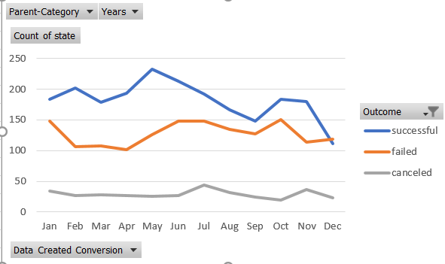

The above chart helps us draw one more import conclusion about the dataset. To have the highest likelihood of success, you should create your Kickstarter complain in May.

**What are some of the limitations of this dataset?**

Limitations of this dataset include the fact that there are many unknowns about the campaigns. One such unknown is how close to a final product are the campaigns. Given technology as an example, we would assume a project that already has a prototype would have a higher likelihood of receiving donations than a project that is still just an idea. Similarly, in theater, a play that already has a script would likely have a higher success rate that a play that is just a summary. Another limitation of that dataset is not knowing who is requesting the Kickstarter campaign. Using technology again as an example, an already existing company may be creating a new product and using Kickstarter to help promote/fund their product. If the company is pre-existing they already have a track record of success and may already have a fallowing who is more likely to donate to the campaign. However, if the campaign is from a startup then they have a harder time earning someone’s trust and therefore money because they don’t have a track record or a following.

**What are some other possible tables/graphs that we could create?**

There are a few other tables/graphs that may offer indications on how to be successful on kickstarter. For one, we have data that tells us when the campaign was created and when the deadline date is. It would be helpful to see the rate of successful campaigns based on length of time. It could be that many campaigns that failed only failed because they picked to short of a deadline date. Another helpful graph would be to see how success rate is impacted by being spotlighted. We would probably assume that being given a spotlight would increase your success rate, but knowing the likelihood that your campaign would success/fail with or without a spotlight may help how you push your campaign.